Student Management Database – Task3
Name : Durgeswari Nayak
Course : SQL Data Analytics

Query -1:
Top student per course
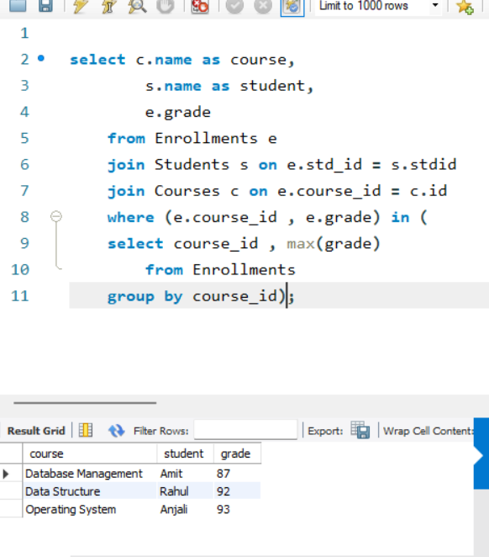

Query – 2:
Pass rate per course (grade >= 40)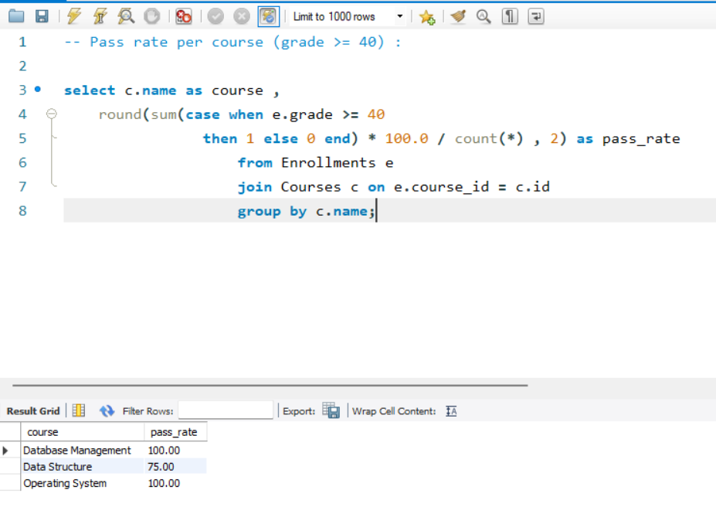

Query – 3 :
Overall topper across all courses
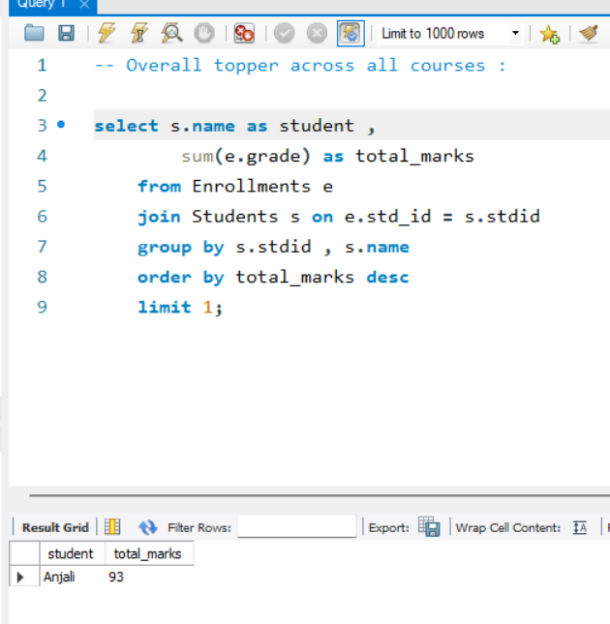

Query – 4 :
Students enrolled in multiple courses
